**Oyster Task Force Meeting**

**Tuesday, May 29, 2018, 1:00pm**

**2021 Lakeshore Dr., STE 210**

**New Orleans, LA 70122**

**Voting-Members Present:**

Dan Coulon

Byron Encalade

Jakov Jurisic

Mitch Jurisich

John Tesvich

Sam Slavich

Willie Daisy

**Voting Members Absent:**

Shane Bagala

Tracy Collins

Leo Dyson

Brad Robin

Brandt Lafrance

Al Sunseri

Peter Vujnovich

**Non-voting Members Present:**

Mark Schexnayder

Justin Gremilion

Captain Chad Hebert

Frank Cole in for Karl Morgan

Motion to approve the April 24, 2018 meeting minutes by Jakov Jurisic, 2nd by Sam Slavich. Motion carries

The board unanimously adopted the May 29, 2018 meeting agenda

**Financial Report:**

Fund Balance: $400,994

Remaining Balance: $95,086

The Task Force expressed their gratitude towards Senator Leopold, Representative Zeringue, and Representative Magee for securing the funds in the oyster related accounts from being striped for budgetary purposes

Task force unanimously accepted the financial report

**Committee Reports:**

**Public-Private Oyster Seed Grounds Committee:**

No report; meeting was postponed until further correspondence is received

**Enforcement report:**

Captain Chad Hebert addressed the board with the committee report

April 15-May 21

**Region 5**: (Cameron, Vermilion)

Cameron

5-Take Undersize oysters from natural reef

4-Violate Calcasieu Lake Oyster Regulations (Oyster Dredge – Tong Only)

                                (Over Limit)

2-Take Oysters Illegal Hours

Vermilion

1-Violate Sanitation Code (Log Book)

1-Violate Sanitation Code (Vessel Sanit. Reg)

**Region 6**: (Terrebonne, Lafourche, Grand Isle)

TERREBONNE

11 – take oysters from an unapproved area

3– take oysters illegal hours

10 – harvest oysters from an improperly marked lease

2 – violate sanitary code (log book)

1 – take commercial fish without a commercial license

1 – harvest oysters without an oyster harvester license

1 – take commercial fish without a gear license (scraper)

1 – take commercial fish without a vessel license

2 – fail to display proper number on vessel

 52 sacks of oysters seized

**Region 8**: (Jefferson, Plaquemines, St. Bernard, Orleans, St. Tammany)

St Bernard

1-Violate Sanitary Code (No Tarp)

8-Fail to Have Written Permission

8-Unlawfully Take Oysters from A Private Lease

2-Unlawfully Take Oysters from Un-leased State Water Bottoms

71 Sacks of Oysters Seized

Task Force requested feedback Cameron Parish violations and repeat offenders, and clarification on the 10 violations for harvesting oysters from an improperly marked lease

**Legislative Committee:**

No report

**Research Committee:**

No report

**Coastal Restoration Committee:**

Dan Coulon provided the Coastal Restoration Committee report

The committee discussed ‘Planning for Management of State Oyster Leasing and Public Seed Grounds Affected by Coastal Projects and Natural Hydrological Changes’

The committee discussed addressing issues per basin:

* East side of the MS River: Brandt Lafrance/ Byron Encalade
* Barataria- Dan Coulon
* West side of the MS River- John Tesvich and Mitch Jurisich
* Lake Borgne- Jakov Jurisic and Brad Robin

Projects on the forefront:

1. Mid Barataria Diversion
2. Mid Breton Diversion (also called medium diversion at White Ditch)

Committee expressed concern with news releases regarding projects coming online getting to outlets in affected areas, requested that all related news be forwarded to news outlets in the following areas:

1. Plaquemines
2. Jefferson
3. St. Bernard
4. Terrebonne

Committee Recommendations:

1. To first consider relocation areas for existing leases in impact zones; *what budget will relocation require?*
2. Accepted the proposed maps as presented, omitting the northern portion of the Lake Borgne area, 2nd by Brandt Lafrance (reference Figure 1 below)
3. Sectioning re-location areas in blocks (i.e. 50-100 acre blocks)
4. Request for LDWF and CPRA to provide the committee with any available data regarding Side Scan Sonar of leases in the proposed impact zones as well as those in proposed relocation areas; *For areas needing data collection: who can complete the work, what are the costs associated, are there other methods used to assess leases’ water bottom quality and shell stock?*
5. Request for LDWF to delineate leases (total number of leases and acreage) in the following areas:
6. Lake Borgne
7. Mid-Barataria from Bayou Lafourche to Four Bayou / Freeport Sulphur Canal (Zone 1)
8. Mid-Breton east of the MS River to Bayou Terre Aux Bouef
9. Request for LDWF to indicate leasable areas in Timbalier Bay and Terrebonne Bay
10. Legal Requests:
11. Asked for feedback on designating areas for relocation that would not be used for new leasing until after relocation program
12. Does enacting a relocation program require legislation or can it be done through rule making (Davis Pond Relocation Program?)
13. CPRA to provide a range of conditions and salinity projections

(CPRA stated that feedback should be available in a two-month time frame)

RECOMMENDATION 2: REFERENCE MAP

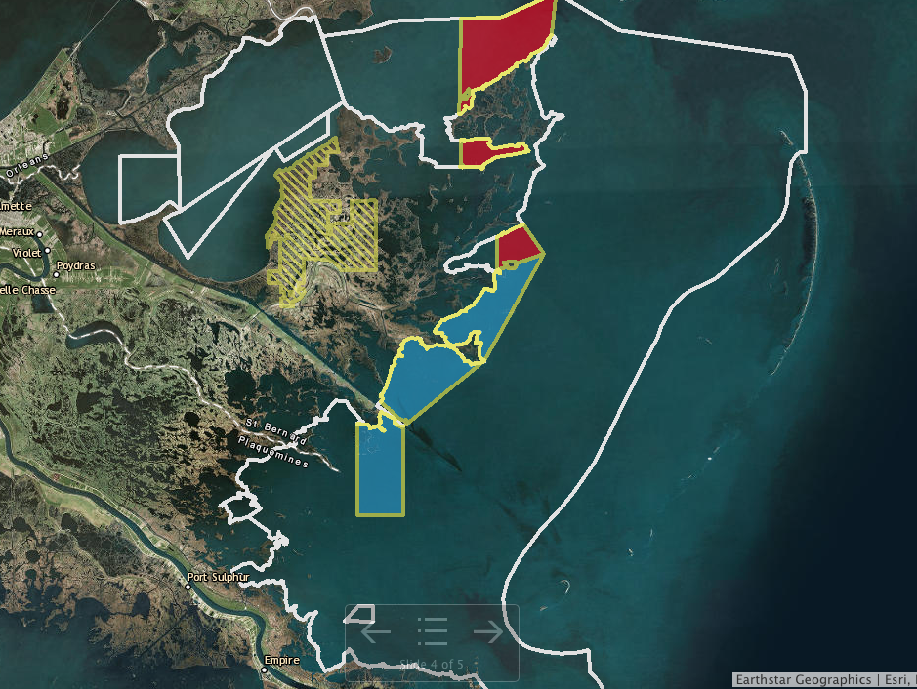

Figure 2

The board unanimously accepted the Coastal Restoration Committee report

Sam Slavich motioned to request legal clarification and opinion on LRS 56:432.1(1) oyster relocation programs and the duties of the state, 2nd by Jakov Jurisic. Motion carries.

**Marketing Committee:**

No report

**Health Committee:**

No report

**Sustainability Committee:**

No report

**Professionalism Report:**

No report

**Aquaculture Committee;**

Allison West read the committee update to the task force provided by the aquaculture chairman, Steve Pollock

1. Go Fish program to support AOC is proceeding. We expect the initial operations to begin in the next 30-60 days.
2. New farmers are being trained at the existing mariculture zone in Grand Isle by Steve Pollock and Mike Roberts
3. New relationships with equipment manufactures are being sought to have local availability of gear for off-bottom oyster culture
4. Seed production is in full swing at Triple N Oysters farm in LA. This is due in part to the extremely successful production of larvae at the Wildlife and Fisheries operated hatchery. Production of triploid larvae has reached record numbers, producing more triploid larvae in a two-month period than the hatchery has produced in the previous 4 years. We are not sure what has changed. We understand restoration work will be the main focus of the hatchery for the remainder of the year.
5. Commercial larvae production has commenced at Triple N Oyster Farm hatchery. The first brood was successfully set this week. This represents the first commercial production of larvae in almost 30 years in Louisiana. Triple N is considering new locations for 2019. It is Triple N’s goal to become a major supplier of triploid and diploid larvae and seed for the AOC in LA and the other Gulf states.
6. The new mariculture zone in Grand Isle is still in the permitting stages the Coast Guard is set to visit the sit this week. The zone consists of 8- 1-acre plots

**Joint Task Force Working Group:**

No report

**New Business:**

Carolina Bourque provided the board with a final update on the 2017-2018 Oyster Season



Sea Grant provided the board with a presentation on the survey results from the LA Fisheries Forward Sediment Diversion Panel

Jakov Jurisic led discussion to consider ordering new shirts that have pockets and name tags with magnetic backings, task force requested options and a budget for their consideration at the next meeting

**Public Comment:**

Jakov Jurisic noticed all military members in light of Memorial Day

Oyster Task Force meeting set for Monday, July 30, 2018 for 1pm in New Orleans

The Coastal Restoration Committee will meet on Monday, July 30 for 9:30am in New Orleans

Motion to adjourn by Jakov Jurisic, 2nd by Willie Daisy. Motion carries.